МИНИСТЕРСТВО ОБРАЗОВАНИЯ И НАУКИ РОССИЙСКОЙ ФЕДЕРАЦИИ

ФЕДЕРАЛЬНОЕ ГОСУДАРСТВЕННОЕ БЮДЖЕТНОЕ ОБРАЗОВАТЕЛЬНОЕ

УЧРЕЖДЕНИЕ ВЫСШЕГО ОБРАЗОВАНИЯ

«НИЖЕГОРОДСКИЙ ГОСУДАРСТВЕННЫЙ ТЕХНИЧЕСКИЙ

УНИВЕРСИТЕТ ИМ. Р. Е. АЛЕКСЕЕВА»

Институт радиоэлектроники и информационных технологий

Кафедра «Прикладная математика»

Лабораторная работа №2

Выполнили:

Студенты группы 20-ПМ-1

Бугрова А.

Кирина Е.

Каретников Н.

Ермолаев Н.

Кочаровский Д.

Проверил:

Доцент кафедры «Прикладная математика»

Чернов А.Г.

Нижний Новгород

2021

# Содержание

**Постановка задачи** **3**

**UML-диаграмма** **4**

**Описание классов в формате отчёта Doxygen** **5**

**Скриншоты работы программы** **6**

**Код программы** **8**

Main.cpp 8

Manager.hpp 11

Manager.cpp 11

Database.hpp 23

Employee.hpp 25

Employee.cpp 26

Task.hpp 29

Task.cpp 30

Makefile 33

2

# Постановка задачи

# 

# UML-диаграмма

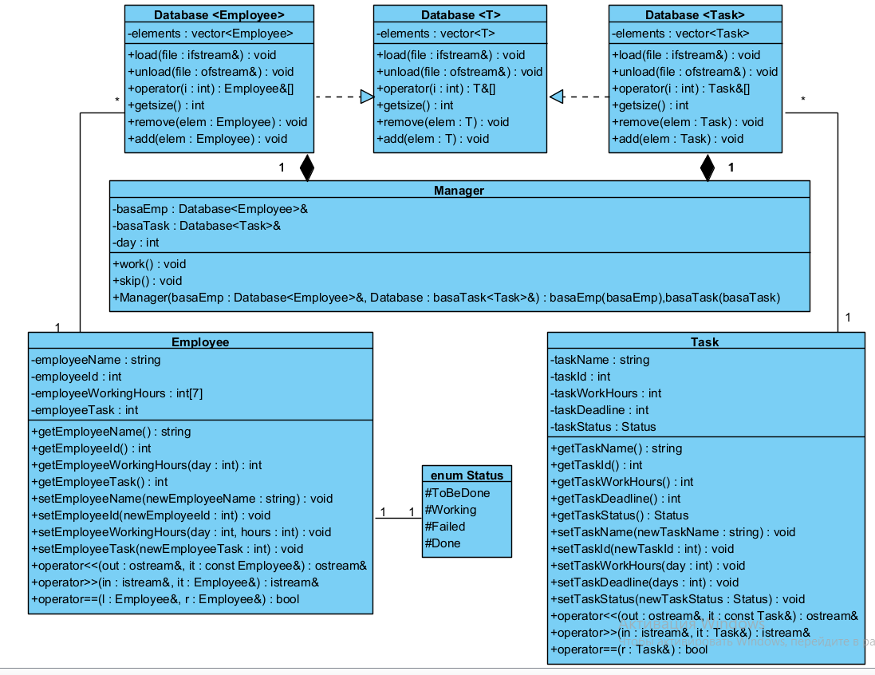

# Описание классов в формате отчёта Doxygen

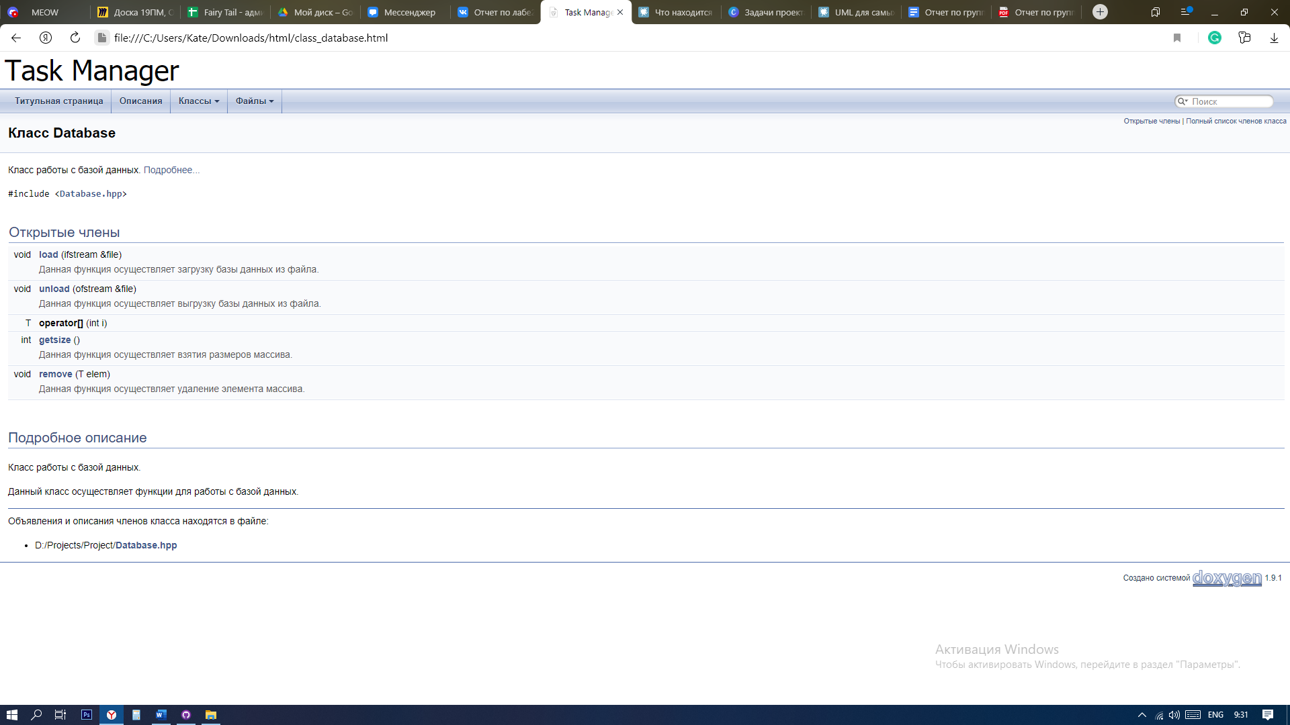

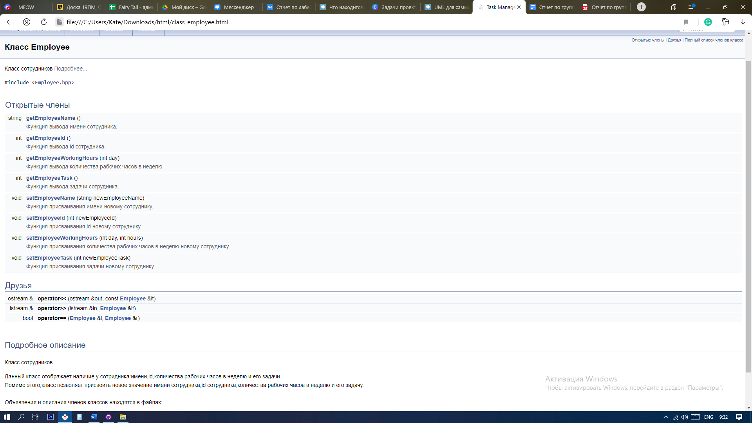

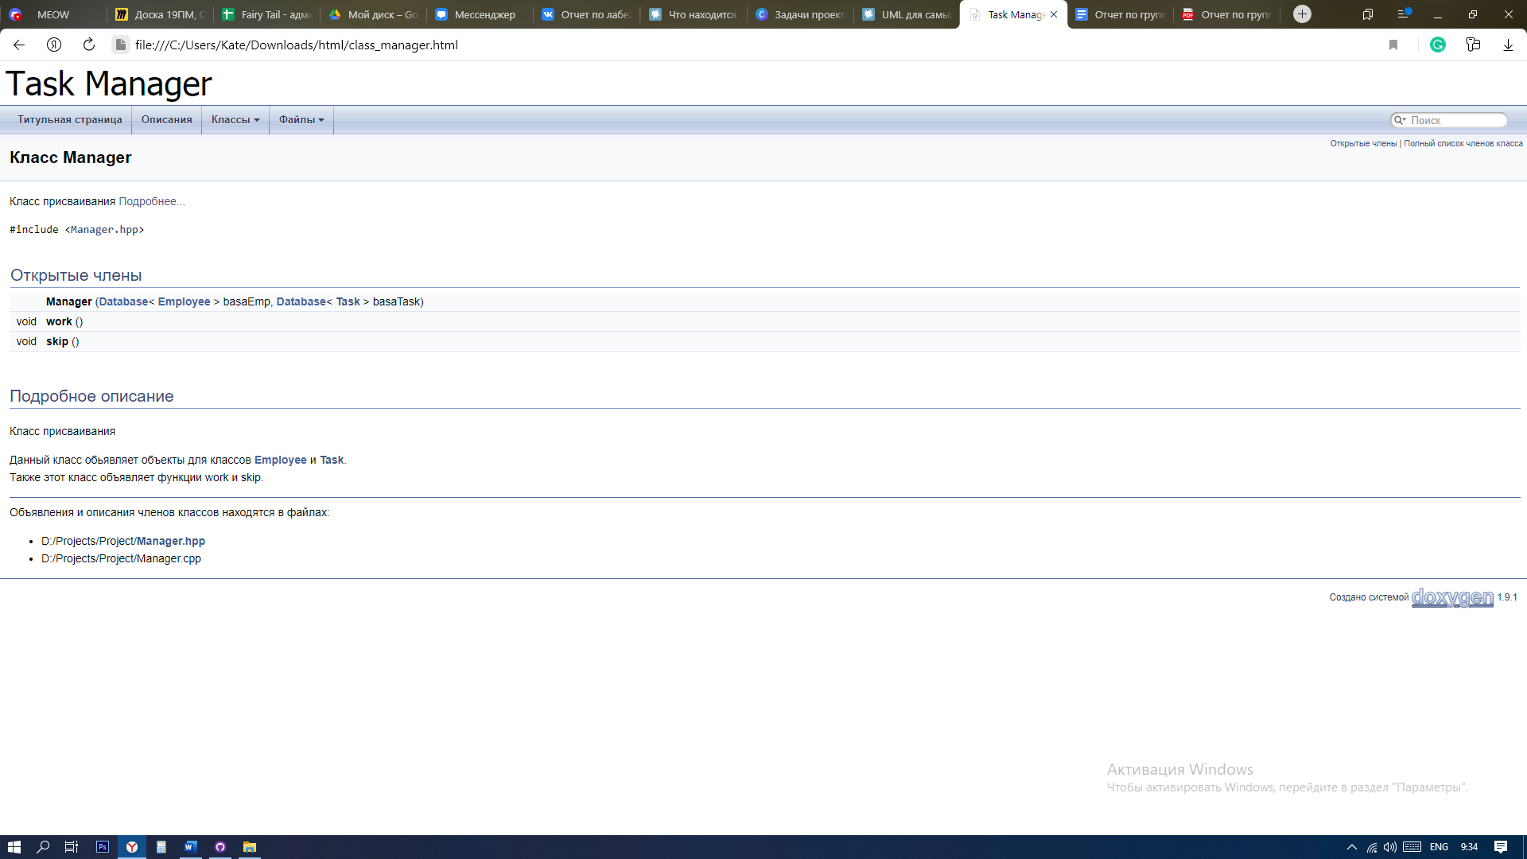

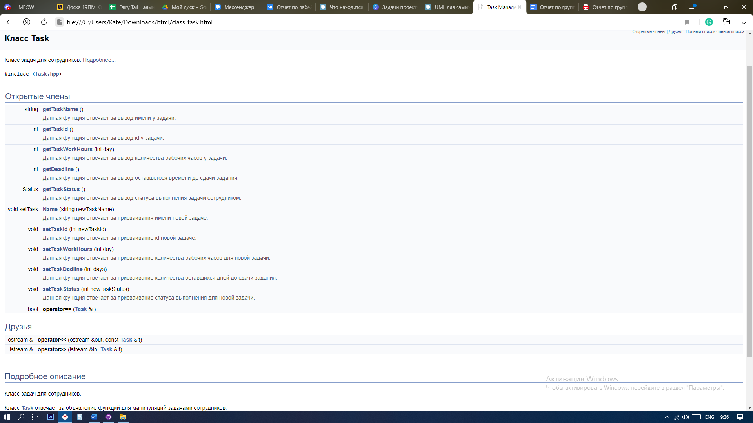

# Скриншоты работы программы

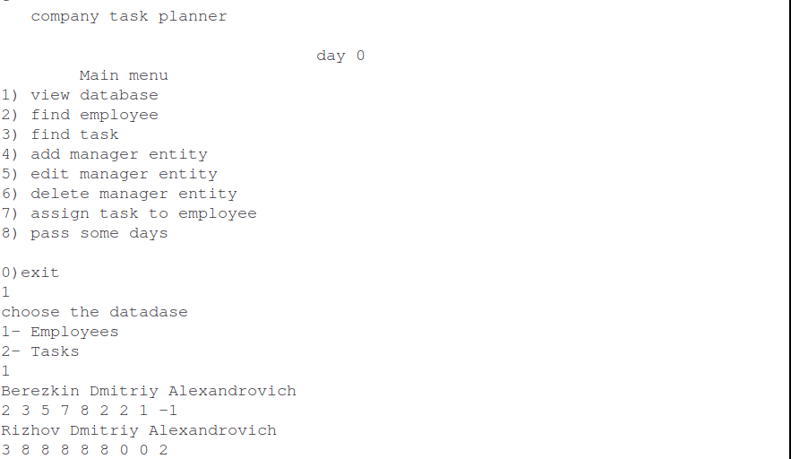

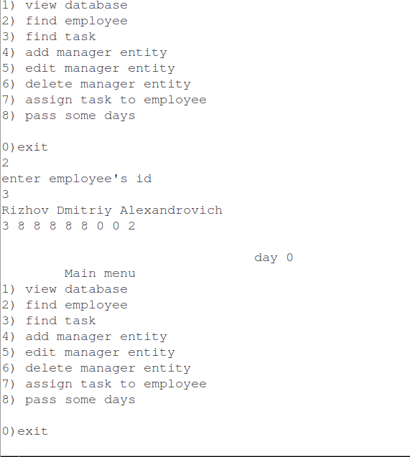

# Код программы

## Main.cpp

#include <iostream>

#include <vector>

#include <fstream>

#include <string>

//#include "Database.hpp"

#include "Manager.hpp"

using namespace std;

/*void opening(ifstream filename, int n)//функция для проверки на открытие файлов с бд

{

//file.open(filename);

if (!filename.is_open())//если не открылся файл то выхоим с программы

{

cout << " !!! THE DATABASE NUMBER " << n << " IS BROKEN !!! " << endl;

exit(0);

}

}*/

int main(int argc, char** argv)

{

if (argc!=3) //проверка на количество аргументов

{

cout << " !!! PLEASE, PROVIDE EXACTLY 2 DATABASE FILENAMES !!! " << endl;

return 0;

}

string employeeName=argv[1]; // переносим название бд в переменные

string taskName=argv[2];

ifstream file1(employeeName);

if (!file1.is_open())

{

cout << " !!! THE DATABASE NUMBER 1 IS BROKEN !!! " << endl;

exit(0);

}

ifstream file2(taskName);

if (!file2.is_open())

{

cout << " !!! THE DATABASE NUMBER 2 IS BROKEN !!! " << endl;

exit(0);

}

//opening(file1,1);// открываем файлы с бд

//opening(file2,2);

Database<Employee> basa1;// загружаем бд в оперативную память и закрываем тектовые файлы

Database<Task> basa2;

basa1.load(file1);

basa2.load(file2);

file1.close();

file2.close();

Manager manager(basa1, basa2);

manager.work();// запускаем работу менеджера

ofstream file11(employeeName); //обновляем текстовые файлы бд и закрываем их

ofstream file22(taskName);

if (!file11.is_open())

{

cout << " !!! THE DATABASE NUMBER 1 IS BROKEN !!! " << endl;

exit(-1);

}

if (!file22.is_open())

{

cout << " !!! THE DATABASE NUMBER 2 IS BROKEN !!! " << endl;

exit(-2);

}

//file11<< "dfghj \n";

basa1.unload(file11);

file11.close();

basa2.unload(file22);

file22.close();

return 0;

}

## Manager.hpp

#include <iostream>

#include "Database.hpp"

using namespace std;

class Manager

{

private:

Database <Employee> &basaEmp;

Database <Task> &basaTask;

int day;

public:

Manager(Database <Employee> &basaEmp, Database <Task> &basaTask):basaEmp(basaEmp),basaTask(basaTask) {}

void work();

void skip();

};

## Manager.cpp

#include "Manager.hpp"

using namespace std;

void Manager::skip()

{

for (int i=0; i<basaEmp.getsize(); i++)

{

if (basaEmp[i].getEmployeeTask() != -1)

{

int code=basaEmp[i].getEmployeeTask();

for (int j=0 ; j < basaTask.getsize() ; j++)

{

if (basaTask[j].getTaskId()==code)

{

basaTask[j].setTaskWorkHours(basaTask[j].getTaskWorkHours()-basaEmp[i].getEmployeeWorkingHours(day%7));

break;

}

}

}

}

for (int i=0; i<basaTask.getsize(); i++)

{

if (basaTask[i].getTaskWorkHours()<1)

{

basaTask[i].setTaskStatus(Status::Done);

for (int i=0; i<basaEmp.getsize(); i++)

{

if (basaEmp[i].getEmployeeTask() == basaTask[i].getTaskId())

{

basaEmp[i].setEmployeeTask(-1);

}

}

}

if (basaTask[i].getTaskDeadline() == 0 && basaTask[i].getTaskWorkHours()>0 && basaTask[i].getTaskStatus() !=Status::Failed )

{

basaTask[i].setTaskStatus(Status::Failed);

}

if (basaTask[i].getTaskStatus()==Status::ToBeDone || basaTask[i].getTaskStatus()==Status::Working){

basaTask[i].setTaskDeadline(basaTask[i].getTaskDeadline()-1);

}

}

day++;

}

void Manager::work()

{

cout << " company task planner" << endl;

char num='-1';

int day=0;

while (num!=0)

{

cout << endl;

cout << " day "<<day;

cout << " \n";

cout << " Main menu\n";

cout << "1) view database\n";

cout << "2) find employee\n";

cout << "3) find task\n";

cout << "4) add manager entity\n";

cout << "5) edit manager entity\n";

cout << "6) delete manager entity\n";

cout << "7) assign task to employee\n";

cout << "8) pass some days\n";

cout << endl;

cout << "0)exit\n";

cin >> num;

switch(num)

{

case '1':

{

cout << "choose the datadase\n";

cout << "1- Employees \n2- Tasks \n";

int a;

cin >> a;

switch(a)

{

case 1:

{

for (int i=0; i< basaEmp.getsize(); i++)

{

cout << basaEmp[i] << endl;

}

break;

}

case 2:

{

for (int i=0; i< basaTask.getsize(); i++)

{

cout << basaTask[i] << endl;

}

break;

}

default:

{

cout << "try again :) \n";

break;

}

}

break;

}

case '2':

{

cout << "enter employee's id \n";

int code;

cin >> code;

for (int i=0; i<basaEmp.getsize(); i++)

{

if (basaEmp[i].getEmployeeId()==code)

{

cout << basaEmp[i] << endl;

break;

}

}

break;

}

case '3':

{

cout << "enter task's id \n";

int code;

cin >> code;

for (int i=0; i<basaTask.getsize(); i++)

{

if (basaTask[i].getTaskId()==code)

{

cout << basaTask[i] << endl;

break;

}

}

break;

}

case '4':

{

cout << "choose the entity\n";

cout << "1- Employee \n2- Task \n";

int a;

cin >> a;

switch(a)

{

case 1:

{

Employee temp;

cout << "enter the name of employee \n";

string name;

getline(cin,name);

getline(cin,name);

temp.setEmployeeName(name);

int id(basaEmp.getsize()+1);

temp.setEmployeeId(id);

cout << "enter work hours \n";

int hour;

for (int i=0; i<7; i++)

{

cin >> hour;

temp.setEmployeeWorkingHours(i,hour);

}

temp.setEmployeeTask(-1);

basaEmp.add(temp);

break;

}

case 2:

{

Task temp;

cout << "enter the name of task \n";

string name;

getline(cin,name);

getline(cin,name);

temp.setTaskName(name);

int id(basaTask.getsize()+1);

temp.setTaskId(id);

cout << "enter hours for working \n";

int hour;

cin >> hour;

temp.setTaskWorkHours(hour);

cout << "enter days to deadline \n";

int days;

cin >> days;

temp.setTaskDeadline(days);

temp.setTaskStatus(Status::ToBeDone);

basaTask.add(temp);

break;

}

default:

{

cout << "try again :) \n";

break;

}

}

break;

}

case '5':

{

cout << "choose the entity you want to edit\n";

cout << "1- Employee \n2- Task \n";

int a;

cin >> a;

switch(a)

{

case 1:

{

cout << "employee's id \n";

int code;

cin >> code;

Employee temp;

for (int i=0; i<basaEmp.getsize(); i++)

{

if (basaEmp[i].getEmployeeId()==code)

{

temp=basaEmp[i];

}

}

cout << "enter new work hours \n";

int hour;

for (int i=0; i<7; i++)

{

cin >> hour;

temp.setEmployeeWorkingHours(i,hour);

}

break;

}

case 2:

{

cout << "task's id \n";

int code;

cin >> code;

Task temp;

for (int i=0; i<basaTask.getsize(); i++)

{

if (basaTask[i].getTaskId()==code)

{

temp=basaTask[i];

}

}

cout << "enter days to deadline \n";

int days;

cin >> days;

temp.setTaskDeadline(days);

break;

}

default:

{

cout << "try again :) \n";

break;

}

}

break;

}

case '6':

{

cout << "choose the entity you want to delete\n";

cout << "1- Employee \n2- Task \n";

int a;

cin >> a;

switch(a)

{

case 1:

{

cout << "enter employee's id \n";

int code;

cin >> code;

for (int i=0; i<basaEmp.getsize(); i++)

{

if (basaEmp[i].getEmployeeId()==code)

{

basaEmp.remove(basaEmp[i]);

}

}

break;

}

case 2:

{

cout << "enter task's id \n";

int code;

cin >> code;

for (int i=0; i<basaTask.getsize(); i++)

{

if (basaTask[i].getTaskId()==code)

{

basaTask.remove(basaTask[i]);

}

}

break;

}

default:

{

cout << "try again :) \n";

break;

}

}

break;

}

case '7':

{

cout << "enter employee's id and task's id \n";

int ecode,tcode;

cin >> ecode >> tcode;

for (int i=0; i<basaEmp.getsize(); i++)

{

cout << "0000";

if (basaEmp[i].getEmployeeId()==ecode)

{

cout << 111;

basaEmp[i].setEmployeeTask(tcode);

basaTask[i].setTaskStatus(Status::Working);

break;

}

}

break;

}

case '8':

{

cout << "enter number of days \n";

int d;

cin >> d;

for (int i=0; i<d; i++)

{

skip();

}

day+=d;

break;

}

case '0':

{

cout << "have a good day \n";

return;

}

default:

{

cout << "please choose correct command \n";

}

}

}

}

## Database.hpp

#include <vector>

#include "Employee.hpp"

#include "Task.hpp"

using namespace std;

template <typename T>

class Database

{

private:

vector <T> elements;

public:

void load (ifstream& file)

{

T temp;

//cout << "fnfuif\n";

while (file>>temp)

{

//cout << temp << endl;

elements.push_back(temp);

}

}

void unload(ofstream& file)

{

//cout << 1;

for (int i=0; i<elements.size(); i++)

{

//cout << elements[i] << endl;

file << elements[i] << endl;

}

}

T& operator[] (int i)

{

return elements.at(i);

}

int getsize()

{

return elements.size();

}

void remove(T elem)

{

for (int i=0; i< elements.size(); i++)

{

if (elements[i]==elem)

{

elements.erase(elements.begin()+i);

break;

}

}

}

void add(T elem){

elements.push_back(elem);

}

};

## Employee.hpp

#include <fstream>

#include <string>

#include <iostream>

using namespace std;

class Employee

{

private:

string employeeName;

int employeeId;

int employeeWorkingHours[7];

int employeeTask;

public:

string getEmployeeName();

int getEmployeeId();

int getEmployeeWorkingHours(int day);

int getEmployeeTask();

void setEmployeeName(string newEmployeeName);

void setEmployeeId(int newEmployeeId);

void setEmployeeWorkingHours(int day, int hours);

void setEmployeeTask(int newEmployeeTask);

friend ostream& operator<< (ostream &out, const Employee &it);

friend istream& operator>> (istream &in, Employee &it);

friend bool operator== (Employee& l, Employee& r);

};

## Employee.cpp

#include "Employee.hpp"

using namespace std;

string Employee::getEmployeeName()

{

return employeeName;

}

int Employee::getEmployeeId()

{

return employeeId;

}

int Employee::getEmployeeWorkingHours(int day)

{

return employeeWorkingHours[day];

}

int Employee::getEmployeeTask()

{

return employeeTask;

}

void Employee::setEmployeeName(string newEmployeeName)

{

this->employeeName = newEmployeeName;

}

void Employee::setEmployeeId(int newEmployeeId)

{

this->employeeId = newEmployeeId;

}

void Employee::setEmployeeWorkingHours(int day, int hours)

{

this->employeeWorkingHours[day] = hours;

}

void Employee::setEmployeeTask(int newEmployeeTask)

{

this->employeeTask = newEmployeeTask;

}

ostream& operator<< (ostream& out, const Employee& it)

{

out << it.employeeName << endl << it.employeeId << " ";

for (int i = 0; i < 7; i++)

{

out << it.employeeWorkingHours[i] << " ";

}

out << it.employeeTask;

return out;

}

istream& operator>> (istream& in, Employee& it)

{

getline(in,it.employeeName);

in >> it.employeeId;

for (int i = 0; i < 7; i++)

{

in >> it.employeeWorkingHours[i];

}

in >> it.employeeTask;

string trash;

getline(in,trash);

return in;

}

bool operator== (Employee& l, Employee& r)

{

bool check = true;

for (int i = 0; i < 7; i++)

{

if (l.employeeWorkingHours[i] != r.employeeWorkingHours[i])

{

check = false;

break;

}

}

return l.employeeId == r.employeeId &&

l.employeeName == r.employeeName &&

l.employeeTask == r.employeeTask &&

check;

}

## Task.hpp

#include <fstream>

#include <string>

#include <iostream>

using namespace std;

enum class Status

{

ToBeDone,

Working,

Failed,

Done

};

class Task

{

private:

string taskName;

int taskId;

int taskWorkHours;

int taskDeadline;

Status taskStatus;

public:

string getTaskName();

int getTaskId();

int getTaskWorkHours();

int getTaskDeadline();

Status getTaskStatus();

void setTaskName(string newTaskName);

void setTaskId(int newTaskId);

void setTaskWorkHours(int day);

void setTaskDeadline(int days);

void setTaskStatus(Status newTaskStatus);

friend ostream& operator<< (ostream &out, const Task &it);

friend istream& operator>> (istream &in, Task &it);

bool operator== (Task& r);

};

## Task.cpp

#include "Task.hpp"

#include <sstream>

using namespace std;

string Task::getTaskName()

{

return this->taskName;

}

int Task::getTaskId()

{

return this->taskId;

}

int Task::getTaskWorkHours()

{

return this->taskWorkHours;

}

int Task::getTaskDeadline()

{

return this->taskDeadline;

}

Status Task::getTaskStatus()

{

return this->taskStatus;

}

void Task::setTaskName(string newTaskName)

{

this->taskName = newTaskName;

}

void Task::setTaskId(int newTaskId)

{

this->taskId = newTaskId;

}

void Task::setTaskWorkHours(int day)

{

this->taskWorkHours = day;

}

void Task::setTaskDeadline(int day)

{

this->taskDeadline = day;

}

void Task::setTaskStatus(Status newTaskStatus)

{

this->taskStatus = newTaskStatus;

}

ostream& operator<< (ostream& out, const Task& it)

{

out<< it.taskName <<'\n'<< it.taskId << ' ' << it.taskWorkHours << ' ' << it.taskDeadline << '\n';

if (it.taskStatus==Status::ToBeDone)

{

out<<"ToBeDone";

}

if (it.taskStatus==Status::Failed)

{

out<< "Failed";

}

if (it.taskStatus==Status::Done)

{

out<<"Done";

}

if (it.taskStatus==Status::Working)

{

out<<"Working";

}

return out;

}

istream& operator>> (istream& in, Task& it)

{

getline(in,it.taskName);

string s;

getline(in,s);

stringstream ss(s);

ss>>it.taskId >> it.taskWorkHours >> it.taskDeadline;

getline(in,s);

if (s=="ToBeDone")

{

it.taskStatus=Status::ToBeDone;

}

if (s=="Failed")

{

it.taskStatus=Status::Failed;

}

if (s=="Done")

{

it.taskStatus=Status::Done;

}

if (s=="Working")

{

it.taskStatus=Status::Working;

}

return in;

}

bool Task::operator==(Task& r)

{

if (this->taskName == r.taskName && this->taskId == r.taskId && this->taskWorkHours == r.taskWorkHours && this->taskDeadline == r.taskDeadline && this->taskStatus == r.taskStatus) return true;

return false;

}

## Makefile

CFLAGS=-c -Wall

all: taskManager

taskManager: main.o Manager.o Employee.o Task.o

g++ main.o Manager.o Employee.o Task.o -o taskManager

main.o: main.cpp

g++ $(CFLAGS) main.cpp

Manager.o: Manager.cpp

g++ $(CFLAGS) Manager.cpp

Employee.o: Employee.cpp

g++ $(CFLAGS) Employee.cpp

Task.o: Task.cpp

g++ $(CFLAGS) Task.cpp

clean:

rm -rf *.o taskManager